Link between false negative results and biopsy size

Intrinsic anomaly vs Adaptative expression
PDL1 expression is spatially and temporarily heterogeneous 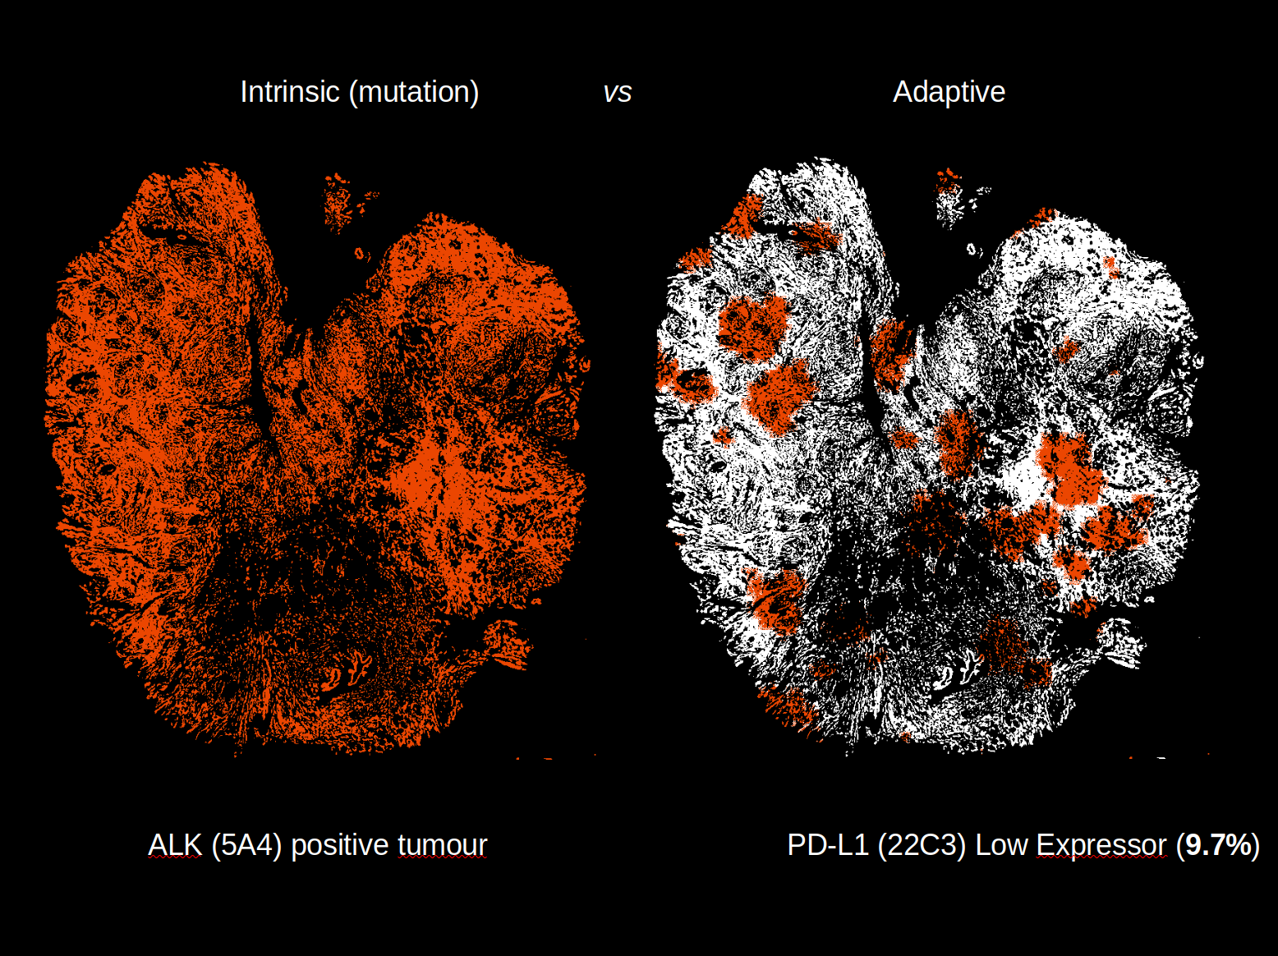

426 NSCLC Alberta 2017 Size Sample Histogram

426 NSCLC Alberta 2017 Size Sample Histogram ZOOM on the smallest samples

PDL1 results small vs large samples

In silicon simulation (1/2)

In silicon simulation (2/2)

